Zhou Yuanyu

222040002

**The preferred strategy of the all-market dark horse fund**

Assignment 3

**ABSTRACT**

The purpose of this strategy is to screen out dark horse funds in the whole market, that is, funds with low institutional attention. The dark horse factor, momentum factor and industry dispersion factor were constructed. The comprehensive factor is constructed by IC mean weighting. Comparison with the Biased Hybrid Fund Index shows that the strategy has significant overweights in the non-huddling market.

**Key words：dark horse factor, momentum factor, industry dispersion factor, IC mean weighting, non-huddling market**

**Contents**

1. Parameter setting 1

2. Factor construction 1

2.1. Dark Horse Factor 1

2.1.1 Define dark horse stocks 1

2.1.2 Define dark horse factor 1

2.2. Momentum factor 2

2.3. Industry dispersion factor 2

2.3.1 Define the proportion of industry holdings of fund A 2

2.3.2 Define the fund industry diversification factor 3

3. IC Mean 3

3.1 Dark Horse Factor 3

3.2 Momentum factor 4

3.3 Industry dispersion factor 4

3.4 Correlation analysis of factor IC values 4

4. Comprehensive factor construction: IC mean weight factor 5

4.1. Define the IC mean weight 5

4.2. The IC mean weight factor is constructed 5

5. Strategy backtesting 5

5.1. Group backtesting results 5

5.2. IC Mean Weight 3 Factor Score Top 20 Funds(2023-03-22) 7

References 7

# **Parameter setting**

|  |  |
| --- | --- |
| Parameter | The range of settings |
| Sample range | All-market active equity-biased public funds, including common equity funds, equity-biased hybrid funds, flexible allocation funds and balanced hybrid funds |
| Backtesting Interval | June 30, 2010 to March 22, 2023 |
| Data frequency | Daily/Semi-annual |
| Frequency of position adjustment | monthly |
| Filter | Initial fund, unsuspended, non-graded fund, the proportion of average stock position in the latest 4 periods is greater than or equal to 60% |

# Factor construction

## 2.1. Dark Horse Factor

Dark horse stocks mainly refer to stocks that are not concerned by investors in the market, suddenly stimulated by a certain kind of positive stimulation, profits may grow explosively in the future, and the trend is very strong in the short term. We define stocks that are less than a certain degree of market value held by the fund as dark horse stocks, and define the dark horse degree of the fund as the proportion of dark horse stocks held, and the higher the dark horse degree, the less likely the fund is to be affected by market sentiment.

However, the performance of dark horse stocks continues to be excellent, and they will gradually become white horse stocks; Or due to company changes, personnel themselves, etc. may also become black swans, so the uncertainty of dark horse funds is relatively high, and the frequency of identification and screening needs to be increased.

### Define dark horse stocks

$$\frac{The market capitalization of the stock held by the fund}{The total market capitalization of the stock}<0.001$$

### Define dark horse factor

$$=\frac{The sum of the market capitalization of the funds held by dark horse stocks}{The total market value of the fund's holdings}$$

## 2.2. Momentum factor

We define the fund momentum factor as a 12-month range return from T-November to T, which can measure the return of the fund in the historical year, and screen funds with positive returns in the short term from a dynamic perspective, and exclude funds with negative returns in the short term. The higher the momentum factor value, the higher the short-term return of the fund, which may lead to higher overweight.

However, the momentum factor is only filtered from the perspective of the net value of the fund, ignoring a large amount of information in the fund's position, which is easy to deviate from the "long-term effectiveness" of the strategy goal; Due to the market huddling, the selected funds may all have heavy positions in certain specific industries, which is prone to both prosperity and loss.

$$Momentum factor=\frac{The net value of the fund at the end of the month t}{The net value of the fund at the end of the month 12 months ago}−1$$

## 2.3. Industry dispersion factor

Funds with diversified holdings are not susceptible to sudden changes in market style. The position of a single stock in this type of fund is small, the impact of the decline in stock price is small, and the risk is relatively low; Stocks in different industries have different trends and elasticity in different periods and different market environments, and there are more trading opportunities, and each stock is not particularly heavy, so high flexibility and high volatility have become the advantages of this type of fund.

We define the industry diversification factor of the fund as the opposite of the proportion of holdings in the top three industries of the fund, and the larger the factor value, the more diversified the fund's industries and the less susceptible to sudden changes in the market industry.

### 2.3.1 Define the proportion of industry holdings of fund A

$$The total market capitalization of the Fund's holdings in Sector A=\sum{The market capitalization of stocks belonging to industry A}$$

$$The proportion of the fund's position in industry A=\frac{The total market capitalization of the Fund's holdings in Sector A}{The total market value of the fund's holdings}$$

### 2.3.2 Define the fund industry diversification factor

$$Industry dispersion factor =−The proportion of holdings in the top three industries of the fund$$

# IC Mean

IC value is correlation coefficient between the factor value of the day and the return of the fund range in the next 21 days. IC mean time series graph is IC mean over 126 days in history.

From the IC figure, it can be seen that the effectiveness of the three factors is strong, and the factors have continuity in the positive and negative directions, representing the degree of effectiveness of the factors in the historical half-year. If the monthly IC value is taken, the turnover rate will be too large and the transaction cost will increase, so 126 days is more appropriate. According to the immediate response of the market, optimize the factor weight, and achieve the effect of timing.

## 3.1 Dark Horse Factor

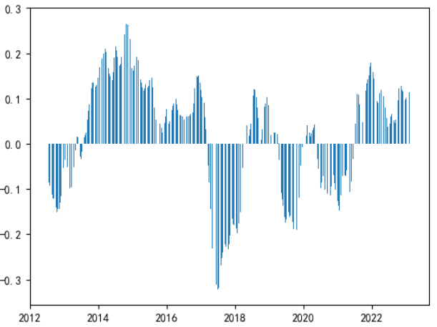

## 3.2 Momentum factor

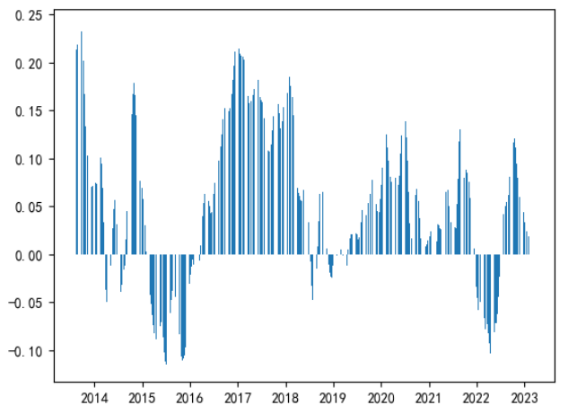

## 3.3 Industry dispersion factor

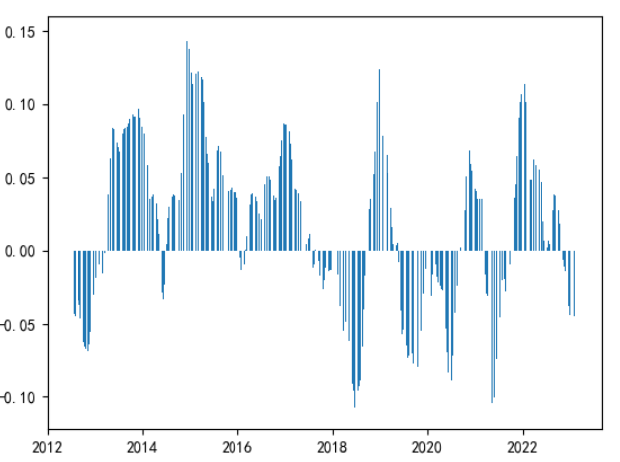

## 3.4 Correlation analysis of factor IC values

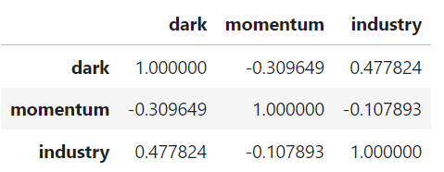

# Comprehensive factor construction: IC mean weight factor

## 4.1. Define the IC mean weight

$$The daily IC value of the factor=ρ( T−day factor value，[t+1,t+21] days' range return of the daily fund)$$

$$IC mean=\frac{\sum_{t−125}^{t}{(Daily IC value of factor)}}{126}$$

$$IC weights=IC mean.shift(21)$$

## 4.2. The IC mean weight factor is constructed

$$IC mean weight 3 factors=∑(The IC weight of the M factor × the normalized M factor)$$

# Strategy backtesting

## 5.1. Group backtesting results

We will divide all funds into 20 groups based on the 4-factor score of IC mean weight, each accounting for 5%, conduct backtesting, calculate the factor score at the end of each month, and adjust the position.

The dark blue (Group 20) in the chart is the group with the highest quantitative score among all funds, indicating that the strategy backtesting stratification is excellent. Group 20 significantly outperformed the other groups, indicating that the strategy has alpha capabilities that exceed the market average.

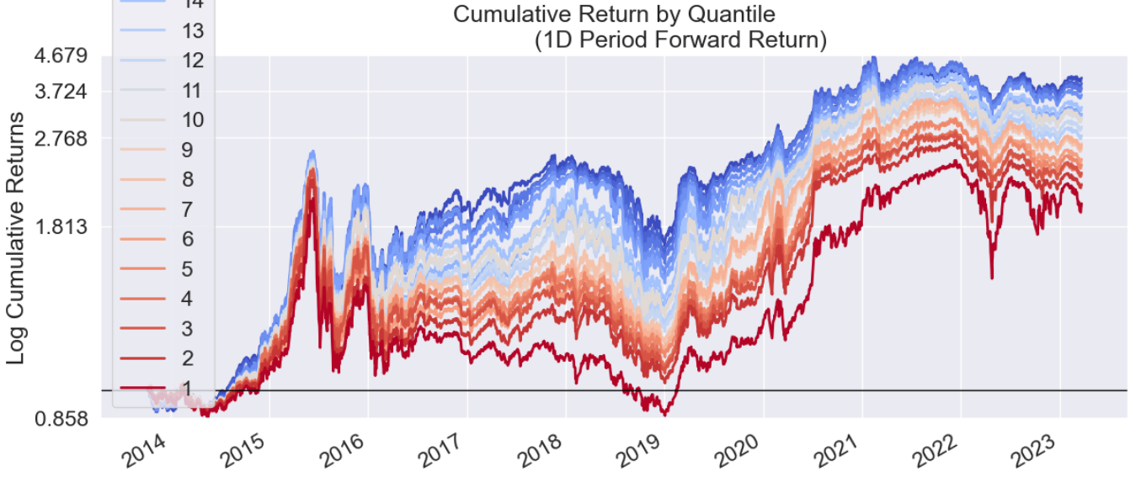

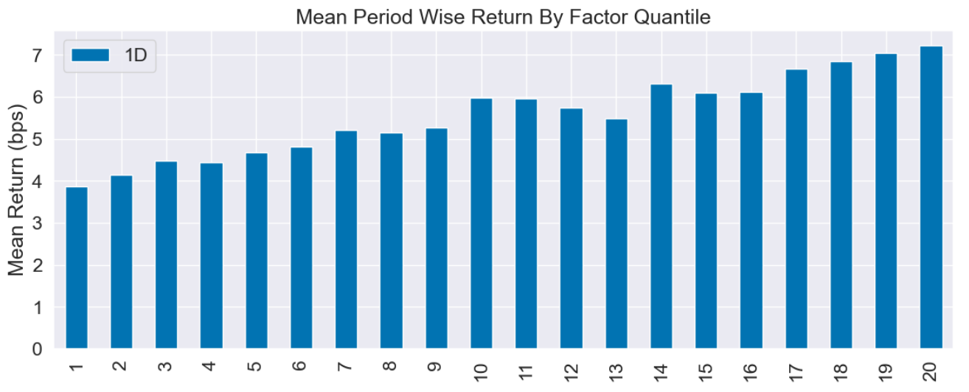

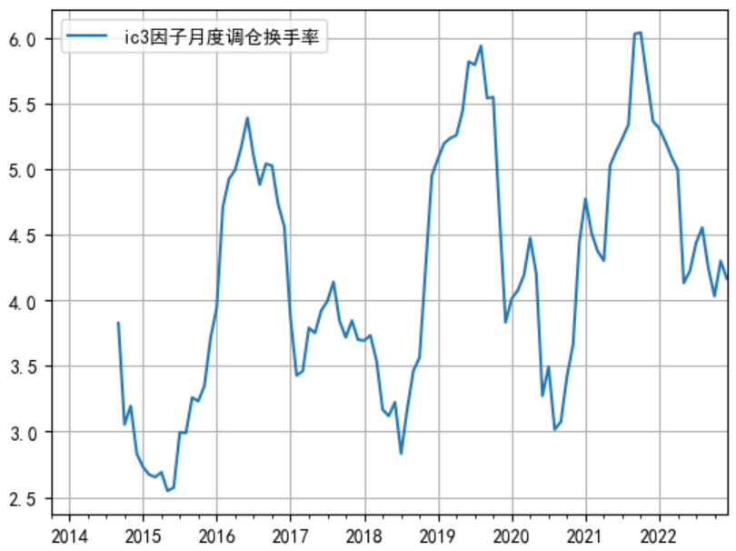

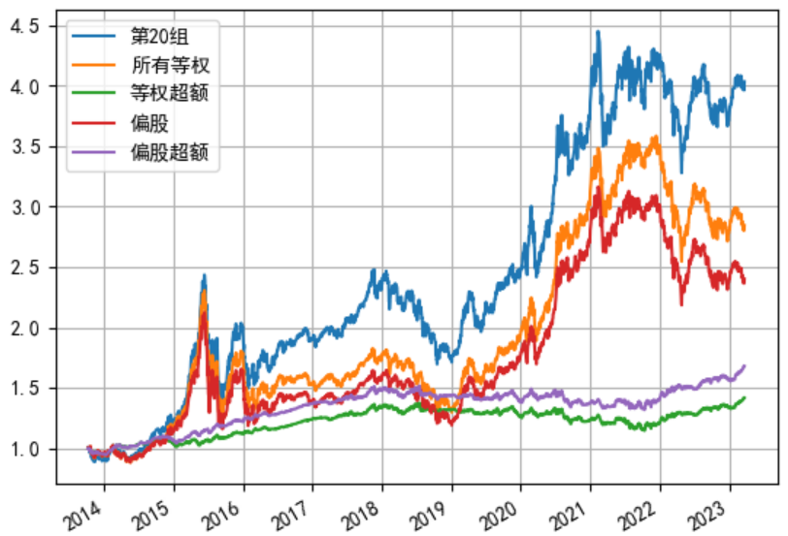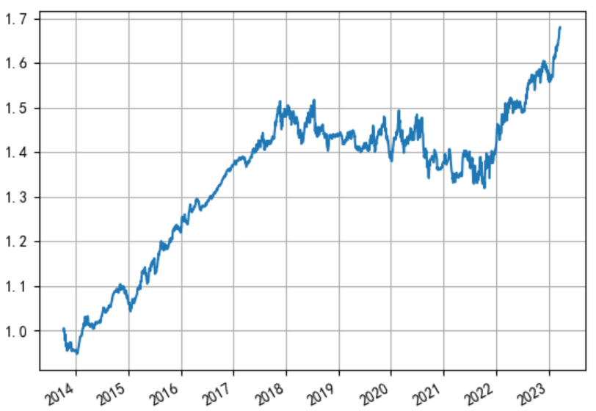

## 5.2. IC Mean Weight 3 Factor Score Top 20 Funds(2023-03-22)

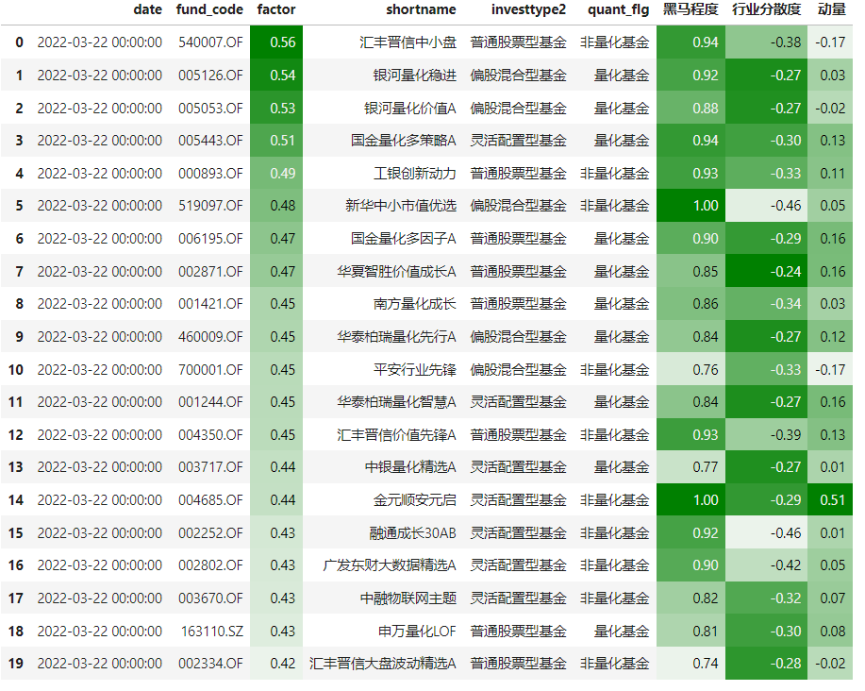

# References

[1]如何在低关注度股票中挖掘alpha，中金证券